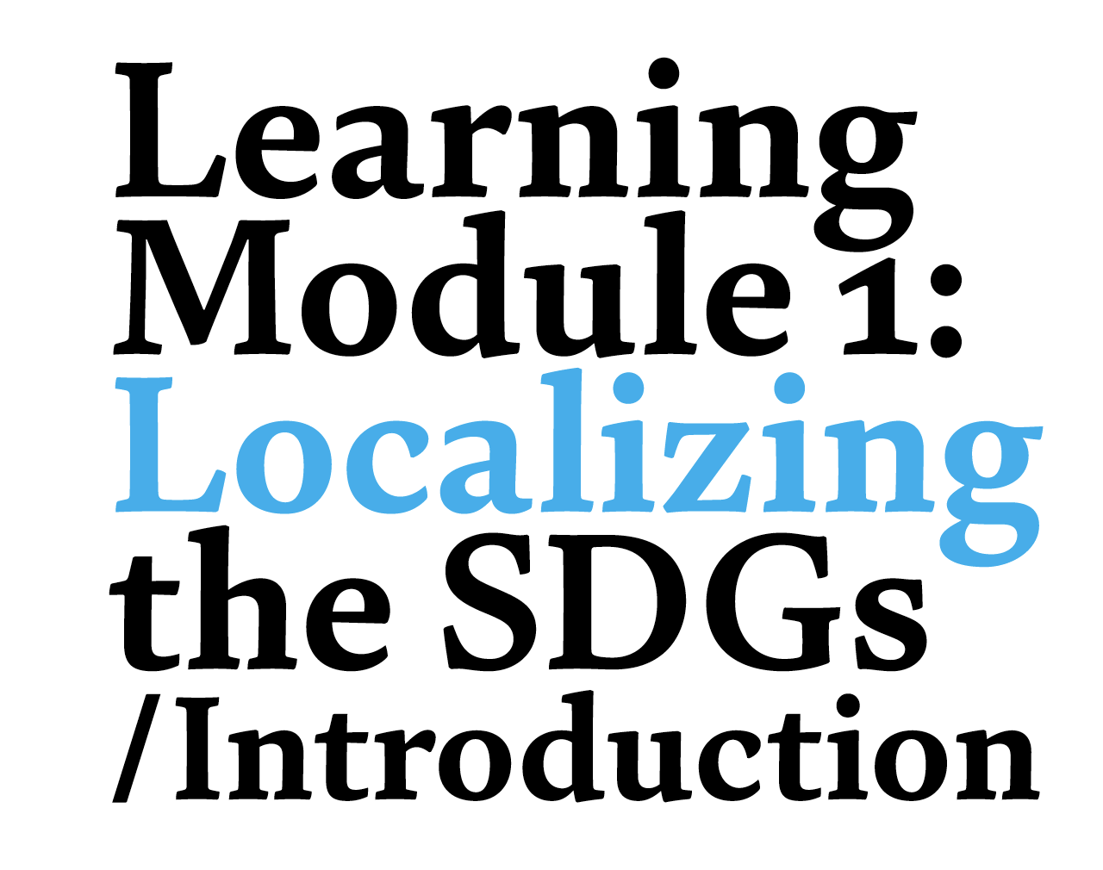

The Trainer´s Guide

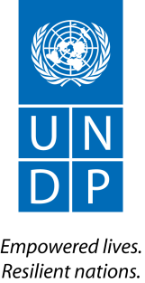
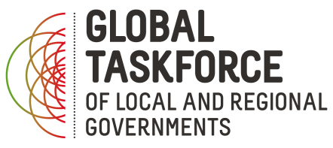

Table of Contents
Presentation 3
Trainer´s background & readings 4
Target audience 4
Methodology 5
Technical information 5
Iconography 5
Complementary materials 6
Glossary 7
Chapter 1: Introduction 7
Introduction to the workshop 7
Differences & similarity between MDGs and SDGs (exercise) 11
The SDGs at a glance (lecture) 12
17 SDGs and MDGs in 5 thematic areas (exercise) 13
SDG principles (lecture) 15
What the community thinks - critical approach to the Agenda (exercise) 16
What does localizing the SDGs mean? (lecture) 17
Why does localizing matter? (lecture) 17
Why are SDGs important for LRGs? (exercise) 18
Key lessons from Chapter 1 20
Chapter 2: Awareness raising, advocacy and dialogues for the localization of the SDGs 21
Introduction 21
The role of local and regional governments in increasing citizen understanding and ownership of the SDGs (Lecture) 21
Why LRG should raise awareness among citizens on SDG Agenda (Exercise) 22
Awareness-raising. Who can do what? (Lecture) 23
Key Chapter 3: SDGs go local. Aligning local and regional development plans 41
Key Chapter 4: Monitoring 50
Anex - example of session planning

Presentation
One year after the Sustainable Development Goals (SDGs) were adopted by the United Nations there still exist local and regional governments (LRGs) who are not sufficiently familiarized with this universal and integrated set of goals. Following the valuable lessons learned from the conclusion of the MDG era, UCLG, UNDP and UN-Habitat have made a great effort to reach LRGs and foster their engagement in the achievement of the SDGs. In this process, the Roadmap for Localizing the SDGs, drawn up by the Global Taskforce of Local and Regional Governments, UNDP and UN-Habitat, offers LRGs a set of strategies that will enable them to take part in this process.
As mentioned in the Roadmap, “all of the SDGs have targets directly related to the responsibilities of local and regional governments”. For this reason, it is LRG elected and appointed officials’ duty to be ready to participate in the localization of the SDGs. In order to achieve this, it is crucial to offer them the necessary tools and knowledge so that they can contribute to this process in their territories and, what is more, articulate other stakeholders’ and the citizenship’s involvement.
The Roadmap is structured in four parts and a conclusion. Each of the four parts offers a different approach to the localization of the SDGs. While they all overlap with each other in time and the results of taking one of the approaches are boosted when working simultaneously on the other approaches, the Roadmap presents the four parts as four separate steps.
In the first place, it is crucial to raise awareness amongst the population (including the citizenship but also CSOs, the academia, the private sector and other stakeholders). But first and foremost, awareness has to be raised amongst those local and regional governments who will subsequently have to take the SDGs into account in their daily work and, in turn, raise awareness amongst the population. In this task, the role of LRG associations is very important.
LRGs also have to play a major role in the adoption of the national plans for the implementation of the SDGs. Principally during the planning stage, but also in the implementation, monitoring and evaluation stages of the plans, LRGs have to advocate for the inclusion of the interests and needs of their territories.
LRG elected and appointed officials will also have to be prepared to develop their own policies, plans, programs and projects aligned with the SDGs. This involves a great deal of different actions, as listed in the Roadmap: conducting a needs assessment, working hand in hand with other actors of the territory or actors with similar needs and perspectives, aligning existing plans with the SDGs, mobilizing resources, and building capacities through a variety of actions, including resorting to development cooperation and peer-to-peer learning with the aim to maximize these actions.
One of the lessons learnt from the MDGs is that subnational data are crucial to ascertain the achievement of the goals throughout a country. This is why the Roadmap emphasizes the need to develop indicators that are specific to each territory, to ensure the data collected are used and that LRGs are included in the monitoring and evaluation stages at local and at national level and, finally, to make sure that national SDG progress reports also reveal local achievements.

Trainer´s background & readings
Any trainer running a learning session based on this Module needs a solid knowledge on the 2030 Agenda and the localization process. We strongly recommend appointing trainers with at least 5 years of hands-on experience working at local or regional level and dealing with global agendas.
Before starting to use this guide we recommend you to read the following texts:
- The Sustainable Development Goals: What Local Governments Need to Know
- From MDGs to Sustainable Development For All: Lessons from 15 Years of Practice
- Local and Regional Voices on the Global Stage: our Post-2015 Journey
- Roadmap for localizing the SDGs: Implementation and Monitoring at Subnational Level
- Getting started with the SDGs in Cities: a Guide for Local Stakeholders
- Localizing the Post-2015 Development Agenda: Dialogues on Implementation
- Delivering the Post-2015 Development Agenda: Opportunities at the National and Local Levels

Target audience
This training or Module is aimed at the development of capacities of LRGs and LRG associations at political and technical level, as well as of other actors who will replicate this training with LRG representatives (representatives of states, international organizations and civil society organizations).
Aware of the huge differences there might exist between the LRGs participating in the Module in terms of competences, territorial scope, composition, etc., this Module is precise but broad enough so as to include and reflect all kinds of LRGs. In order to achieve this, in some occasions specific material for metropoles and/or for regional governments is provided.
Three different groups are proposed according to the different target audiences that could be the object of this Module.
- Group 1: elected representatives and officials of LRGs with poor knowledge of the Agenda 2030 but good knowledge of the local sphere
- Group 2: elected representatives and officials of LRGs with good knowledge of the Agenda 2030 and of the local sphere
- Group 3: representatives of regional and national LRGs Associations, national Governments and national and local stakeholders (CSOs, private sector, academia)
Some exercises will be adaptable not only for a group type but also according to the following categories: region, metropolis, medium-sized city, LRG association. These categories will be marked in the margin of the document.
While most of the actions proposed are addressed at all three groups, the approach will be different depending on the capacities of the participants: for those participants with greater knowledge on the SDGs a deeper understanding of the impact of these goals at local level might be needed, while representatives and officials from small towns and cities might need a more thorough knowledge of what SDGs are but might more easily understand how local governments can contribute to them.

Methodology
In this Trainer´s Guide you will find information that will allow you to conduct a training session about Sustainable Development Goals. The document is divided into four Chapters:

Chapter 1: Introduction
Chapter 2: Awareness raising, advocacy and dialogues for the localization of the SDGs
Chapter 3: SDGs go local!
Chapter 4: Monitoring, follow up & evaluation

Each of them is designed as an independent learning module divided into shorter units with given timings so that you can adjust and apply the given methodology in different contexts (4 to 6h long trainings) also depending on the group level, number of attendees etc. The different contents, which are more practical than theoretical, are flexible so that you can adapt them to the reality, needs and aspirations of the attendees, that is, the political, economic, social and cultural environment of their territory.
At the same time, the Chapters present real case-studies and best practices from different regions of the world with the main aim of offering a more practical view based on success stories, but also as a way to encourage LRGs in development and decentralized cooperation experiences, as pointed out in the Roadmap.

Technical information
The optimum size of the group for a training based on this methodology is from 12 to 16 people. For bigger groups we strongly recommend having two or more trainers, especially for the exercises that require moderation.
The space where you will run the learning session should be equipped with a projector, wi-fi and a flipchart. It should have movable chairs and tables so that you can easily rearrange the room for exercises. This will also allow the participants to sit and move according to their needs.

Iconography
Throughout the Guide you will find a series of icons that will help you find the information more easily and move around the Chapters. Learning materials are divided into two general categories: lectures and exercises marked with the following icons:

Lecture
Exercise

Every lecture and exercise are accompanied by additional icons:

 | Group | It shows a recommended target group type: 1, 2 or 3
 | Slides | It shows which slides should be used
 | Time | It shows estimated times
 | Handouts | It shows which handouts should be used
 | Resources | It shows resources: publications, videos

Apart from the icons, on the left margin you will also find tips and information as to whether any previous preparation is needed, like printing, cutting materials etc.

Below each section you will find additional resources such as links to useful publications, videos and websites.

Complementary materials

This Trainer’s Guide is accompanied by complementary materials:
- Presentation with a visual support for the training based on the Guide’s key information and graphics
- Handouts for the participants with instructions, key information, summaries of the different modules etc.

Glossary

CSOs – Civil Society Organizations
ECOSOC – United Nations Economic and Social Council
HLPF – High-Level Political Forum
LRGs – Local and Regional Governments
MDGs – Millennium Development Goals
SDGs – Sustainable Development Goals
UCLG – United Cities and Local Governments
UNDP – United Nations Development Programme
UN-Habitat – United Nations Human Settlements Programme
VNR – Voluntary National Reviews

Chapter 1: Introduction

Introduction to the workshop
Icons:
10 - 15 min,
Group 1,2,3

Option 1: Survey

Filling out the survey takes no more than 15 min. You should send it to participants a couple of days before the training. We are proposing a survey, but feel free to make your own version. The proposed survey is available here.
Analyze the results beforehand and start the session by sharing some interesting facts and figures that you have found out from the survey.
Examples:
- 62% of you believes that SDGs and targets are interlinked, and the achievement of one Goal requires addressing the others too
- 85% of the LRG carries out awareness-raising campaigns for the achievement of the SDGs

Option 2: Introductory video

Showing a dynamic video is a very appropriate beginning for any training. There are many high quality videos on SDGs that you can use. Our recommendations are:

- We the people (https://www.youtube.com/watch?v=RpqVmvMCmp0&t)
- Transitioning from the MDGs to the SDGs (https://www.youtube.com/watch?v=5_hLuEui6ww&t)
- No point going half way (https://www.youtube.com/watch?v=DdLqiTvFwJk)
- Leave no one behind (https://www.youtube.com/watch?v=pBqe8JD62QE&t)
- Numbers in action (https://www.youtube.com/watch?v=Mdm49_rUMgo)

Resources

United Cities and Local Governments YouTube channel
The Global Goals YouTube channel
UN YouTube channel

Option 3: Presentation round

Tip: You should have the list of all participants and their positions before the training.

Tip: If you prefer to start with the video or the presentation round, not the survey, feel free change the order or use only one of the mentioned.

If there are less than 15 people, ask everyone to briefly present themselves on the forum. If the group size exceeds 15, divide the participants into groups of 5 and ask everyone to present themselves to the group.

From the MDGs to the SDGs (lecture)
Icons:
10 min,
Group 1
slides: 1
handout: 1

Tip:
After introducing the video on the transition from MDGs to SDGs you can complement it with this UNDP video. (Slide x)
Tip:
Take into consideration that not all the participants are familiar with the jargon. Make sure to always explain each abbreviation when you introduce it for the first time. If you work with a Group 1, it will be very helpful if you hand in the Handout 1- Glossary.

This lecture is interesting as it shows the beginners the transit from one agenda to the other. This allows them to understand the crucial evolution that SDGs represent in terms of universality and integrality of the challenges LRGs will face from now on.
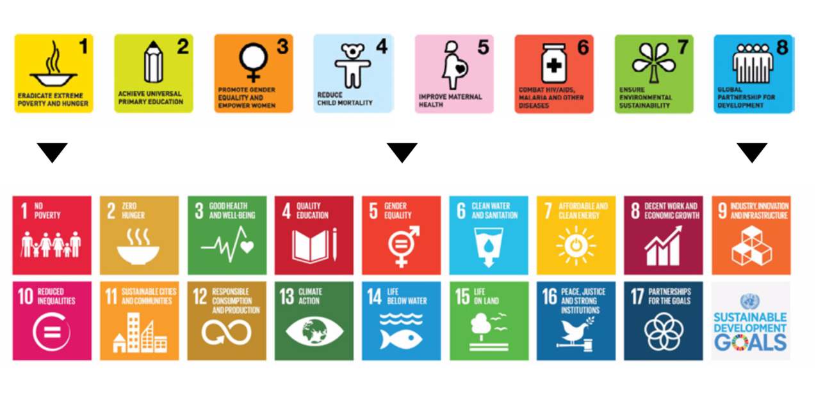(slide x )

Trainer’s insights:
The Millennium Development Goals (MDGs) were an expression of solidarity with the world’s poorest and most vulnerable. The Goals mobilized the world to tackle poverty’s many dimensions, forming a framework for a global partnership that ushered in a new era of development cooperation. Yet for all the achievements, the international community faced many challenges during this 15-year journey.
Many countries mainstreamed the MDGs into their national and sub-national development plans and strategies, and implemented specific measures intended to achieve the associated targets. However, progress was uneven and, in spite of best efforts, many countries missed one or more of the MDG targets.
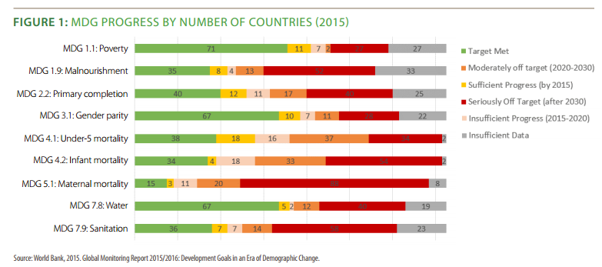
In this link you can find more information on the progress made by the countries of your trainees in the implementation of the MDGs.
The 2030 Agenda for Sustainable Development now sets the vision for the next 15 years of global action. It encompasses the unfinished business of the MDGs and goes well beyond poverty eradication, breaking significant new ground. It is a universal, integrated and human rights-based agenda for sustainable development. It balances economic growth, social justice and environmental stewardship and underlines the links between peace, development and human rights. Implementation should not create 17 new silos around the Sustainable Development Goals.
Resources:
Library:
Regional and country progress reports. UNDP
http://www.undp.org/content/undp/en/home/librarypage/mdg/mdg-reports.html
Transitioning from the MDGs to the SDGs. UNDP
http://www.undp.org/content/undp/en/home/librarypage/sustainable-development-goals/transitioning-from-the-mdgs-to-the-sdgs.html
Video:
Transitioning from the MDGs to the SDGs
https://www.youtube.com/watch?v=5_hLuEui6ww

Differences & similarity between MDGs and SDGs (exercise)
Icons:
20 min
Group 1
Handout 2

Preparation:
Remember to print and cut out the cards from Handout 2. You will need an adhesive tape.

Tip: If there are more than 11 participants, prepare 2 set of cards and use 2 flipcharts to make sure that everyone participates. One participant should have more than one card.
Divide a flipchart into two empty columns with the titles: MDGs and SDGs. Mark one raw with a different colour and explain that there is one similarity between SDGs and MDGs and 10 differences. Distribute 22 cards to the participants and ask them to stand up and place their card in a correct place.
The 10 major differences and 1 similarity between MDGs and SDGs
MDGs | SDGs
8 goals and 21 targets | 17 goals and 169 targets
Top-down approach: result of an intergovernmental agreement and high level consultations | Bottom-up approach: issued from an unprecedented consultation process (2012-2015)
Tackling poverty | Sustainable development
Developing countries | Universal
The world’s poorest and most vulnerable | The world’s population
Specific challenges | Integrated and comprehensive Agenda: covers the 3 dimensions of SD (economic, social and environmental)
Governmental | Inclusive: engagement of stakeholders (LRGs, community based organisations, CSOs, private sector, academia etc.)
Statistical approach to localizing (urban rural disaggregation) | Comprehensive approach to localizing. The local dimension of SDGs should be
Measurable through 60 indicators | Measurable through 230 indicators
Focus on aid flows and development cooperation | Focus on domestic resources to fund sustainable development strategies
Clear, concise, time-bound and measurable | Clear, concise, time-bound and measurable

The SDGs at a glance (lecture)
Icons:
20 min
Group 1
Presentation slide: 4,5

Tip: during the lecture hand in the copy of What Local Governments need to know to all participants.

Preparation: order or download and print the copies of Sustainable Development Goals: What Local Governments need to know (UCLG publication)

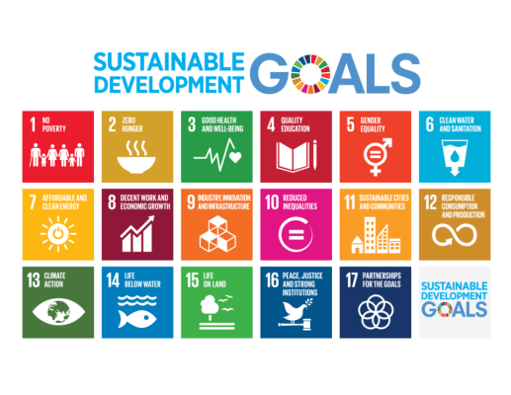
(slide 4)

This lecture proposes an overview of the new Agenda, its goals and targets and the way they are linked to local and regional competences and responsibilities.

The Sustainable Development Goals are an ambitious set of 17 goals and 169 targets that were defined and developed through an unprecedented dialogue among UN Member States, local authorities, civil society, the private sector and other stakeholders.
The Preamble of the Agenda 2030 identifies 5 thematic areas: people, planet, prosperity, peace and partnership – the 5 P’s of the SDGs.

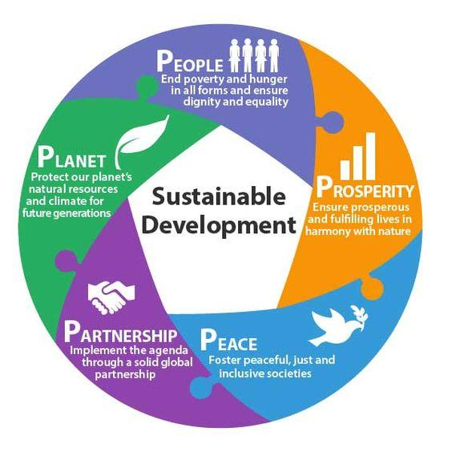
(slide 5)
Stress the local dimension of SDGs. Explain that all of the SDGs include targets related to the competences and responsibilities of LRGs, particularly to their role in delivering basic services and promoting integrated, inclusive and sustainable territorial development.
Recommend the following publication where the participants will find a concise presentation of targets related to LRGs competences:
Sustainable Development Goals: What the local Governments need to know

For more information on every specific goal, click here.

17 SDGs and MDGs in 5 thematic areas (exercise)
Icons:

30 min
Group 1, 2
Slides: xxx
Handout: no. 3, 4, 5

Tip: Use SDG Memory Game and ask participants to put the corresponding cards on each thematic field.

Preparation: print out the handouts, cut out the cards. You will need a glue stick for each group.

Divide the participants into smaller groups of 3 to 5 people. Distribute to each group the cards from handout no. 3 (a list of SDGs) and handout no. 4 (5 thematic areas). Give the participants 10 minutes to assign each of the 17 SDGs to one of the thematic areas.
When the groups are ready, show slide 6 and ask if there were different answers in any group. Discuss any doubts that may appear.

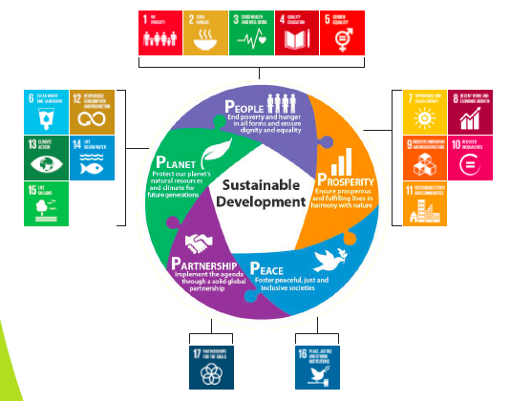
(slide number 6)
As the second part of the exercise give each group the MDG cards (handout number 5) and ask them to assign each MDG to the same 5 thematic areas. Give them 5 minutes to discuss with the group members. When the time will have run out, show the graphics of slide 7 with the correct answers. Ask which group got the same result. If there are doubts on the correct answers discuss it with participants. Use the information below:
Trainer’s insights:
The 17 SDGs can be divided into the 5 thematic areas and compared to the MDGs as follows:
- 5 of the 17 SDGs focus on people ending poverty and fighting inequality, ensuring healthy lives, knowledge & inclusion and empowerment of women and children.
- In the framework of the MDG agenda, 6 of the 8 goals focused on people.
- 5 of the 17 SDGs focus on the planet (water and sanitation, sustainable consumption, fighting climate change, marine and terrestrial ecosystems).
- Only 1 MDG focused on the planet and it was extremely wide (sustainable development)
- 6 of the 17 SDGs focus on prosperity calling for new strategies for sustainable business, finance and socio-economic development.
- The MDGs made no reference to the socio-economic dimension.
- 1 SDG refers to peace, justice and accountability as key concepts for sustainable development (SDG 16).
- SDG 17, as MDG 8 did, focuses on the need to promote a new partnership to catalyze global solidarity for sustainable development.
Resources:
SDGs Knowledge Platform
https://sustainabledevelopment.un.org/
SDGs. Changing the world in 17 steps. The Guardian
https://www.theguardian.com/global-development/ng-interactive/2015/jan/19/sustainable-development-goals-changing-world-17-steps-interactive
Communications material - UN
http://www.un.org/sustainabledevelopment/news/communications-material/
UCLG SDG Memory Game

SDG principles (lecture)
Icons:
10 min,
Group 1, 2, 3
handout
Presentation slides: 8
Use the presentation slides x, y, z and briefly explain the SDGs’ principals:
- Based on experience: the SDGs are built on the experience and lessons learned from the MDGs.
- Multi-dimensional approach to sustainable development: sustainable development, understood as a set of interlinked trajectories of social, economic and environmental evolution
- Leave no one behind: the 2030 Agenda is for all people
- Global in nature: the SDGs address the most pressing global challenges of our time
- Universal nature: the Agenda applies to all the countries in the world regardless of income levels
- Integral nature: the 2030 Agenda is all-encompassing and interconnected in all its dimensions and at all levels: between goals, between countries, and between global, regional and national levels
- Inclusive: the Agenda implicates all levels of government, all stakeholders and all people in an inclusive and collective effort for sustainable development. This underscores the idea of the 2030 Agenda as a global partnership for sustainable development
- Measurable: the Agenda puts particular emphasis on the need to measure performance and results through a set of indicators in order to evaluate the achievement of the SDGs and draw lessons and recommendations

What the community thinks - critical approach to the Agenda (exercise)
Icons:
20 min,
Group 2, 3

Tip: It is very hard to predict the intensity of the debate, as it will depend on how strong the participants’ personal opinions are on the Agenda. However, by using the following table you will be able to moderate the debate more easily.
Divide the flipchart into two columns and name them ‘Pros’ and ‘Cons’. Encourage participants to take part in a plenary discussion by asking What is their personal opinion on the 2030 Agenda. Write down the first answer in the corresponding column and ask what would be a counterargument. Ask for a second opinion and proceed the same way.

For example, if the first answer is that the Agenda is utopic write it down on the ‘Cons’ column and ask participants if they agree and what would be a counterargument (‘Pros’). You will find examples in the table above.

Pros | Cons
 | Utopic
 | Abstract
 | Too complex
 | Too wide or broad
 | Does not include some key challenges such as migrations
 | Difficult to measure at the local level
 | Business as usual
 | ...

References:
- Foreign Policy: The SDGs should stand for senseless, dreamy, garbled. http://foreignpolicy.com/2015/09/28/the-sdgs-are-utopian-and-worthless-mdgs-development-rise-of-the-rest/
- The Economist, 15 march 2015. The 169 commandments. http://www.economist.com/news/leaders/21647286-proposed-sustainable-development-goals-would-be-worse-useless-169-commandments

What does localizing the SDGs mean? (lecture)
Icons:
10 min,
Group 1, 2, 3
Presentation slides: 10, 11, 12

Tip: you can use SDG 11 animation (slide x)
The lectures on what localizing the SDGs means and why it matters are the key parts of Chapter 1. For this reason, they should be introduced for every target group and be present even in the shortest versions of the learning session.
Use slides 10, 11, 12 to introduce the participants to the concept of localization of the SDGs.

Localizing refers to the process of adapting, implementing and monitoring the SDGs at the local level.

Localization is the process of taking into account subnational contexts in the achievement of the 2030 Agenda, from setting the goals and targets to determining the means of implementation and using indicators to measure and monitor progress.

Localization relates both to:

- how local and regional governments can support the achievement of the SDGs at national level by means of action carried out from the bottom up and
- how the SDGs can provide a framework for local development policy

SDG 11 on sustainable cities and human settlements is the lynchpin of the localization process. Its inclusion in the 2030 Agenda is the fruition of the advocacy work of the broad urban community (particularly local and regional government associations) as well as of the growing international recognition of the importance of the subnational dimension of development. Linking SDG 11 with the urban and territorial dimensions of the other 16 goals will be an essential part of the localization of the SDGs.

Why does localizing matter? (lecture)
Icons:
10 min,
Group 1,2,3
Presentation slides: 13,14,15,16

While the SDGs are global, their achievement will depend on our ability to make them a reality in our cities and regions. All of the SDGs have targets directly related to the responsibilities of local and regional governments, particularly to their role in delivering basic services (slide 13). That is why local and regional governments must be at the heart of the 2030 Agenda.

UN Secretary General Ban Ki-moon sent a clear message in this regard, recognizing that, in a rapidly urbanizing world, “our struggle for global sustainability will be won or lost in cities” (slide 14). Cities and regions are ideally positioned to transform the broad and abstract 2030 Agenda into a concrete and efficient one. They can approach goals and targets in a pragmatic way, fit them into their own particular context and help their citizens understand how local action contributes to their achievement.

The achievement of the SDGs depends more than ever on the ability of local and regional governments to promote integrated, inclusive and sustainable territorial development. As stressed in the Synthesis Report of the UN Secretary General, “many of the investments to achieve the sustainable development goals will take place at the subnational level and be led by local authorities” (slide 15). There is a long way to go if this reality is to be recognized by national legal and political frameworks, and national and international advocacy works on behalf of local and regional governments remains necessary.

Local spaces are ultimately the key site of delivery and development and as such the local government is central to the success of sustainable development. South African Local Government Association (SALGA)

Subnational governments should not be seen as mere implementers of the Agenda. Subnational governments are policy makers, catalysts of change and the level of government best-placed to link the global goals with local communities.
UCLG. What Local Governments need to know

(slide x)

Why are SDGs important for LRGs? (exercise)
Icons:
15 min,
Group 1,2,3
handout:

Divide the participants in small groups or pairs. Give each group 5 minutes to come up with 1 or 2 reasons why LRGs should be involved in the achievement of the Agenda. Ask each group about their answers and use a flipchart to write them down. At the end add and explain the answers that you think are missing and distribute handout no. x to the participants.

- Provide a shared narrative of sustainable development and help guide the public’s understanding of complex challenges.
- The SDGs provide an integral framework for sustainable development at local level
- Be involved in the global community.
- The commitment of LRGs with the global agenda promotes their recognition and legitimation as key actors of the global sustainable development system.
- The recognition of LRGs as key actors for sustainable development enables them to claim for better political and economic frameworks at national level.
- The 2030 Agenda recognizes LRG leadership at territorial level and their capacity to articulate territorial stakeholders for sustainable development.
- Mobilize domestic and international financial resources for local sustainable development.
- Look for capacity building initiatives focusing on the reinforcement of LRGs’ operative and institutional capacities.
- Reinforce statistical institutions specialized in collecting data at local and regional level.
- Roadmap for decentralized cooperation.

The Agenda 2030 in the countries of your trainees (Lecture)
To finalise this chapter it is important to contextualise the level of engagement of the country/countries of your trainees with the 2030 Agenda. With this aim, it is important that the you provide framework-information on the following questions:
- Did the country/countries of your trainees approve a national strategy to implement the SDGs?
- Did LRGs participate in the elaboration process of the national strategy?
- Are there governance platforms (multi-level and multi-stakeholder) for the monitoring of the national strategy? Are Local and Regional Governments taking part in those platforms?
- Are Local and Regional Governments participating in the Agenda? How? Through awareness raising initiatives? Aligning their development strategies to the SDGs?
To answer this and other related questions you might pose, following this link you can log in the online review platform, dedicated to compiling information from countries participating in the voluntary national reviews of the High-level Political Forum on Sustainable Development. You will find information on your country of interest. It is possible to filter this information by suggested keywords such as “local government”.
Pay attention! Filters use keywords in English and do not recognize keywords in other languages.

Resources:
Voluntary national reviews
https://sustainabledevelopment.un.org/vnrs/

Key lessons from Chapter 1
Group 1
- Raise awareness on the challenging importance of sustainable development in all its dimensions (economic, social and environmental) and on the crucial role of LRGs.
- Encourage the participants’ engagement in the localization process and show the benefits of being engaged with the 2030 Agenda.
Groups 2 and 3
- Raise awareness on the importance of sustainable development in all its dimensions (economic, social and environmental) as a universal challenge and on the crucial role of LRGs.
- Share the reasons for a critical approach to the Agenda and identify its added values.
- Encourage the participants’ engagement in the localization process and show the benefits of being engaged with the 2030 Agenda.

Chapter 2: Awareness raising, advocacy and dialogues for the localization of the SDGs

Introduction
This chapter will focus on the relationship between LRGs and the territorial stakeholders and citizenship as a whole. The aim will be to make the 2030 Sustainable Development Agenda known amongst them and foster their involvement in the definition, implementation, monitoring and evaluation at local, regional and national stage.
Real experiences will prove that LRGs have the necessary potential to promote awareness-raising and education campaigns aiming to involve the citizenship and other stakeholders in this new Agenda. These campaigns will reinforce the universality of the Agenda, as well as the citizens' bond and commitment with this set of goals shared worldwide. In addition, they will bolster the local dimension of the Agenda insofar that an important part of the targets is in the hands of LRGs and will only be achieved if all territorial stakeholders get involved.
This involvement should guarantee that their interests, aspirations and needs are included in the local strategies for the implementation of the SDGs. It is thus crucial to create platforms for citizen participation and coordination with the territorial stakeholders and to ensure that citizens, CSOs, universities and the private sector participate in the process of definition of the Agenda at local level as well as in its implementation, monitoring and evaluation.
Likewise, the knowledge acquired about the needs and interests of the citizens and territorial stakeholders should be used by LRGs and particularly by their associations in their actions for advocating in the process of definition of national sustainable development strategies and their implementation, monitoring and evaluation. This chapter will analyze different experiences that have developed in countries from all around the world that have established open platforms for the participation of the different levels of government and, in some occasions, of other stakeholders, with the aim to coordinate the implementation of the 2030 Agenda at national level

The role of local and regional governments in increasing citizen understanding and ownership of the SDGs (Lecture)
Icons:
5 min,
Group 1,2,3
Presentation slide: 18

The lecture on the role of LRGs in increasing understanding and ownership of the SDGs is a key content in this chapter and it should be presented to all the groups. As a visual support for the lecture use slides x,y,z.
Trainer´s insights
National and subnational governments, civil society organizations, the private sector, academia and individual citizens should all be involved in the implementation and monitoring of the SDGs. Awareness-raising campaigns should be carried out at both national and subnational levels, mobilizing and building partnerships with different local stakeholders, bringing together all sectors of society, boosting their participation and ensuring that diversity is embraced (drawing knowledge, legitimacy, participation and enhanced effectiveness from local people of all cultures, genders and origins).
As the closest level of government to the people, local and regional governments are well-placed to raise awareness about the importance of the SDGs and their relevance to local communities (slide 17). Subnational governments bridge the gap between central governments and communities and should play a strong role in fostering the involvement of civil society organizations, the private sector (micro, small and medium enterprises), academia and other community-based organizations. Locally elected leaders, in particular, have a democratic mandate to lead local development and can be held accountable by citizens if they fail to do so.

Why LRG should raise awareness among citizens on SDG Agenda (Exercise)
Icons:
20 min,
Group 1,2,3

Tip: If you are running a half- day training with the group 3 resign from awareness- raising exercises (ladder, stakeholders mapping, focus on lecture parts and stimulate debates. The saved time you should use later on the advocacy parts .
Draw a ladder on the flipchart and ask participants Why LGR should raise awareness among citizens on the SDG Agenda?
Place all the answers on a ladder starting from the basics, which is to provide information to the citizens. The highest step should be controlling the implementation of the Agenda, which only can be done when the citizens have a sense of ownership, are engaged and actively participate in the implementation of 2030 Agenda.
Ladder of suggested answers:
TOP STEP- 5. To empower citizens to monitor the Agenda (the highest level of participation)
4. To empower citizens to be involved in the implementation
3. To built a sense of ownership of the Agenda among citizens

2. To engage citizens with the 2030 Agenda

BOTTOM STEP - 1. To provide information (the lowest level of participation)

Trainer´s insights
Democratic accountability is a powerful tool to drive the achievement of the SDGs at local level. Awareness-raising activities should aim to increase the engagement of citizens and local communities in order to promote their sense of ownership of the Agenda and their participation in the achievement of the SDGs at local level. But awareness-raising is not only about letting citizens know about the existence of the SDGs. It is also about empowering them to participate in the achievement of the SDGs in their daily lives. Local and regional governments should be supported to recognise the 2030 Agenda as a framework for action, and set up mechanisms that enable citizen participation and institutional accountability.

2 (Lecture)
Icons:
20 - 30 min,
Group 1,2,3
Presentation slides: x, y, z

This lecture consists of brief explanation of the roles of LRG and LRGA in building awareness on the SDGs. Put more focus on one or the other group dependently on the profile of the trainees. If you have enough time use case studies to illustrate the lecture.

Local and Regional Governments

Local and Regional Governments
- - Embrace the SDGs as their own policy framework
- - Elaborate a strong awareness-raising and communication campaign
- Involve both existing and new platforms
- Reach all sectors of society
- Harness the power of culture to make the SDGs engaging
- Take advantage of the power of education
- Include a gender perspective
- Promote champions to maximize efforts

slide x

Local and regional governments in those countries where the MDGs were pursued should build on networks and organizations that were involved in the MDG process, as well as on the Agenda 21 programme and sustainable development strategies. At the same time, they should also use the SDGs as a fresh start to engage with a broader cross-section of actors, such as the private sector and community organizations, and to launch new forms of collaboration and participation.
Public awareness-raising campaigns should focus on the message that the SDGs are relevant to ordinary people all over the world. The SDGs cover issues that are directly relevant to citizens’ daily lives, including vital challenges such as poverty, gender inequality, climate change and insecurity, as well as public goods like education, health, water, energy, air quality, housing and the conservation of natural resources.
Activities that can be undertaken to raise awareness among the population should make the SDGs engaging and harness the power of local culture. Such activities could include concerts, bike rides, campaign buses, fairs, events showcasing success stories, award ceremonies, and collaboration with well-known figures (e.g.: actors, musicians, sportspeople, writers, and photographers) or foundations that can act as ambassadors for the SDGs. The planning of activities should include a gender perspective to ensure that women and girls are not excluded. Subnational governments should reach out to the traditional media, for example through training and activities for journalists, and use their social media channels to communicate the SDGs directly to citizens.
Additional: Case Study - Valencia
Icons:
10 min,
Group 1, 2
Presentation slides: x

The new government of the region of Valencia (Spain), formed in July 2015, understands the 2030 Agenda for Sustainable Development as "a new opportunity, perhaps the last, to transform the world” and, for this reason, considers necessary a firm commitment to bring the region in line with this Agenda. The challenge of localizing the agenda is tackled through three strategic vectors, namely information, awareness and commitment, that are broken down into 3 operational levels of activity: the municipal/regional level, the national level and the global level.
Several activities are promoted to develop these vectors. The provision of information aims at generating reflection among the public and political officials on why compliance with the agenda is in the interest of all of the Region's social and economic actors, and this includes trainings on the SDGs for both public employees and the creation of a MOOC open to all citizens. Raising awareness through development education campaigns in educational institutions from a global citizenship perspective encompasses actions such as local art exhibitions and the development of an education strategy and materials for the youth according to their age. Finally, the creation of partnerships between the public administration, the private sector and civil society is essential in order to encourage the commitment of all local stakeholders, for which reason the setup of two official bodies (a High Level Advisory Council and an Interdepartmental Commission) is foreseen, together with that of an alliance amongst the Valencian public universities, the engagement of the private sector through public-private partnerships and the creation of an alliance of cities for SDG implementation. All these actions and aims have been formulated in a strategy shared and agreed upon by the members of the community which clearly go beyond development cooperation policies and focuses on all of the Government’s and local stakeholders’ actions.
Source: The Region of Valencia and the local implementation of the SDGs: A region committed to Cooperation and the 2030 Agenda for Sustainable Development. May 2016. Generalitat Valenciana
Local and Regional Government Associations and Networks
Local and Regional Associations and Networks

- Carry out national and international campaigns to increase commitment amongst LRGs
- Support LRGs in their awareness-raising campaigns
- Nominate champions among local and regional governments
slide x
Some local and regional governments may be unaware of their role in the 2030 Agenda, or fear that they are too small or lack the necessary knowledge or capacity (human, technical or financial resources) to contribute to the achievement of the SDGs.
Local and regional government associations and networks should carry out awareness-raising campaigns to mobilize their members to understand their role in the achievement of the SDGs. They should seek to increase the knowledge and sense of ownership of the SDGs by all subnational governments, regardless of their size or level of resources, with the support of national governments and international organizations.
Local government associations should make local and regional governments aware of their role in both the implementation of the SDGs and in the definition and evaluation of national and territorial strategies, as well as take steps to strengthen the institutional and operational capacities of their members. The awareness-raising and communication campaigns of local government associations should aim to build the commitment of local and regional institutions and other stakeholders to localize the 2030 Agenda, as well as to support their national and international advocacy work.
The nomination of champion local and regional leaders who are actively involved in the achievement of the SDGs can be a powerful awareness-raising and mobilization tool for local and regional government associations. Calls for champions should be organized by national associations at national level and by the Global Taskforce of Local and Regional Governments at global and regional levels (Africa, Asia, Europe, Latin America, etc.). These champions should communicate the SDGs and the importance of localizing them. As pioneers in SDGs implementation, champions should promote the recommendations and share their experiences, ideas and perspectives in their communities, countries and worldwide at conferences, meetings, and public events.
Additional: Case study - VNG Time Capsule
Icons:
10 min,
Group 3 (LRGA)
Presentation slides: x

This case study is particularly interesting for Local and Regional Governments Associations. Enter the link to the VNG Time Capsule website and explain the project. Ask participants if they think that this is a good awareness raising campaign and why they think so. Encourage them to give other examples of campaigns in their territories.
VNG Time Capsule is a project run by VNGI (International Cooperation Agency of the Association of Netherlands Municipalities) together with all municipalities in the Netherlands, that aims to raise awareness of the Global Goals. “Time capsule” travels across the country to engage municipalities in the journey towards 2030. Mayors and aldermen are invited to formulate their personal wish or dream for the year 2030 in relation to the Global Goals. The first personal wishes have already been added to the Time Capsule.
Resources:
VNG Time Capsule: http://www.vng-international.nl/blog/c/

Mapping: Who the stakeholders are and how to engage them? (exercise)

Icons:
80 min,
Group 1, 2, 3
slides
handout x

Tip: If possible have a moderator working with each group.
Preparation: Print 1 copy of handouts x, x for each group.
Mapping is a group exercise where trainees have to draw a map of stakeholders and possible projects that engage them in localizing the SDGs. There is no one correct way of doing it. Every group will surely come up with different answers and will choose different ways to structure the map. The goal of this exercise is not to reach the ´correct answers´ but to stimulate debates and to help see the complexity of localizing the SDGs. However if you see that the participants miss any of the key stakeholders form handout x, moderate the group discussion to help them see the missing puzzle.
Divide participants into smaller groups of 4 - 6 people. Each group should sit around a table with a flipchart paper sheet and marker pens placed on it.
The mapping exercise is divided into 4 stages:
- 10 min - Each group has to choose a case study for the exercise. We provide you sample case studies: Sample City, Sample Region, Sample Polis (handout x) that participants can use as a point of reference for the mapping. However, we recommend you to use examples that are closest to participants. If possible, divide trainees into groups from the same city or region and ask them to work on the real case or encourage one person from each group to describe their local context and base a mapping exercise on it.
- 25 min - Who are the stakeholders? - Each group has to work on the identification of local stakeholders in the process of localizing the SDGs. Moderate in group debates to help them come up with the answers: CSO, private companies, academia, schools, other levels of public administration as key stakeholders in the implementation as well as follow-up and review of the SDGs.

Tip: If you see that it is hard for a group to grasp such a broad context you can narrow the exercise by choosing only one SDG and ask the group to come up with stakeholders directly connected with it.

Tip: You can also use cards from the handout x (with stakeholders names) to make the exercise shorter or if you see that a group has difficulties to come up with any answers.

- 30 min- 3 project examples that engage the stakeholders? When the groups are ready with the list of stakeholders ask them to come up with 3 examples of local projects that engage the stakeholders. During the discussions they should see that ownership, accountability, and inclusiveness are the key to stakeholder engagement and they should have it a criteria when choosing the best 3 propositions

- 15 min - Presentations. Each group should hang it´s map in a place visible to all participants (a wall, a whiteboard, a flipchart etc.) and briefly, in 3 to 5 min, explain the map to the rest of the trainees.
Tip: You can use the 3 projects from the mapping later in the alligning exercise.

Resources:
Making Global Goals local business: a new era for responsible business
https://www.unglobalcompact.org/library/4321
El Sector privado ante los ODS: Guía práctica para la acción:
http://www.pactomundial.org/wp-content/uploads/2017/02/Guia_ODS_PM_20170215_web.pdf
Guide pratique. Entreprises, contribuez aux Objectifs de développement durable!
http://bl-evolution.com/etudes/guide-pratique-objectifs-developpement-durable-entreprises-2016/
The contribution of a sustainable economy to achieving the SDGs
http://nachhaltigeswirtschaften-soef.de/en/sustecon-conference

Advocacy. What for? (Lecture)

Icons:
15 min,
Group: 2,3

This lecture is of a special importance to associations. You should always connect it to the debate exercise that follows it.
Tip: Check if the countries of you trainees has submitted or has committed to submit the VNRs and make a reference to it during the lecture.
Building national consensus

National governments all over the world are launching SDG-based national development strategies or aligning their existing plans with the proposed goals of the 2030 Agenda.
National associations of local and regional governments have an important task in facilitating the participation of local and regional governments in the development of these national strategies so that they reflect and respond to local circumstances, needs and priorities. Promoting local ownership of national strategies is vital. If local and regional governments have a sense of ownership of the SDGs and a role in determining their roles and responsibilities, their involvement in implementation will be greater.
All levels of government should work to build national consensus that places the SDGs at the centre of national, regional and local development. Subnational governments should be proactive in resisting top-down approaches that reduce their role to implementing priorities decided unilaterally by their central governments. Local and regional governments should seek to ensure that the process is bottom-up, and that local needs, priorities and expectations frame national strategies. Where there is no integrated planning process in place, local and regional governments can call for the opportunity to participate in the definition of national priorities, strategies and institutional frameworks.
In the advocacy process, subnational governments should provide evidence to back up their messages and arguments. Local and regional governments will be more influential if they contribute to the debate with a consolidated political message based on their knowledge and experience. If possible, local and regional governments should collaborate with universities and research institutes to gather the necessary evidence to support their advocacy work.

BOTTOM-UP APPROACH (Exercise)
Icons:
25 min,
Group: 2,3
slides: x

This section is designed as a plenary debate. Use the slide x to briefly explain the bottom - up approach model and use the questions below to generate debate around it.

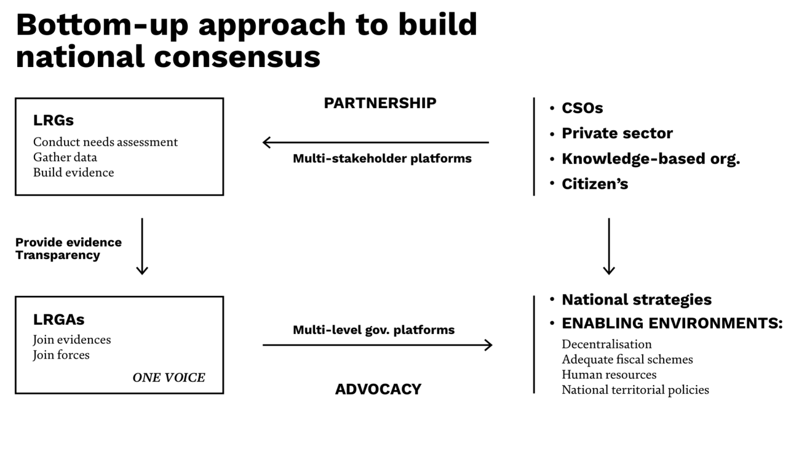
In order to generate some debate over the importance of advocacy through a bottom-up approach, the following questions could be posed to the audience:
- Based on the previous diagram, do you think LRGs have direct access to influence the national level, or do they have to go through their LRG associations?
- What would happen if no consensus was reached within the LRGAs, that is, if unbridgeable opinions and priorities were given by the different LRGs? What could LRGAs do in their attempt to advocate before the national level?
- On what matters do you think there could arise differences of opinion amongst LRGs that could pose a problem for the LRGAs?
- How important do you think it is for local stakeholders to advocate towards the creation of an enabling environment at national stage?
- In short, what is the added value of bottom-up approaches with respect to top-down approaches? Are bottom-up approaches applied in your territory concerning other fields of action?

5 Key elements of Advocacy. (Exercise)
Icons:
60 min
Group: 2,3
slides: x
handout: x

Preparation: For each group print handout x

Divide participants into groups of 3 to 5 people. The exercise has 4 stages:

- 5 min- Give handout x to each group and explain it briefly on a forum
- 15 min- Each group should come up with 2 arguments on WHY transparency, networking, knowledge and data, communication, multi- level governance are important for effective advocacy.
- 20 min - Each group, basing on their local experiences, should write down at least one good practice for each of 5 categories
- 15 min - Presentations of the outcome

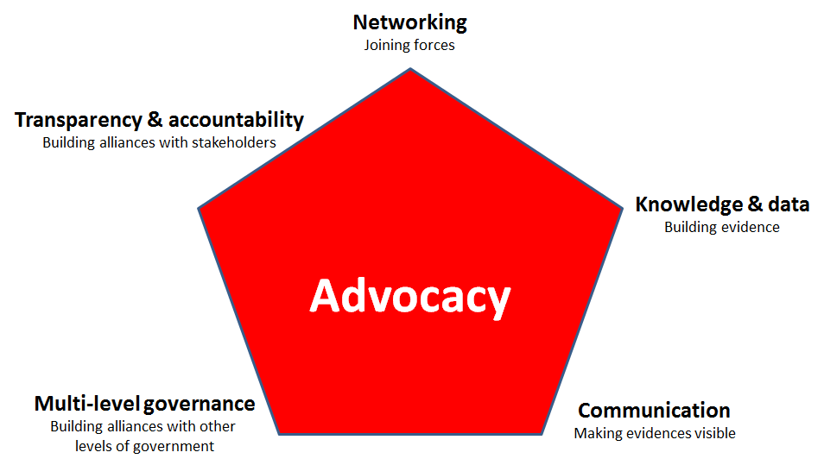
handout x

Call for an enabling environment for the localization of the SDGs (Lecture)
Icons:
60 min
Group: 2,3
slides: x

The SDGs and their localization present a fresh opportunity to strengthen the decentralization agenda and promote new forms of cooperative governance (multi-level and multi-stakeholder).
Local and regional governments and their associations should take advantage of the international commitment to localize the 2030 Agenda and call for reforms that give them clear competencies and create enabling environments in which to ensure effective local and regional development. National legislation and regulations provide the frameworks within which local and regional governments act. Such frameworks can create incentives or obstacles for sustainable development, especially in relation to local resource management, fiscal and financial decentralization, inclusive economic development and environmental protection. It is therefore essential that national local and regional government associations advocate for an enabling environment for the implementation monitoring and assessment of the SDGs at subnational level.
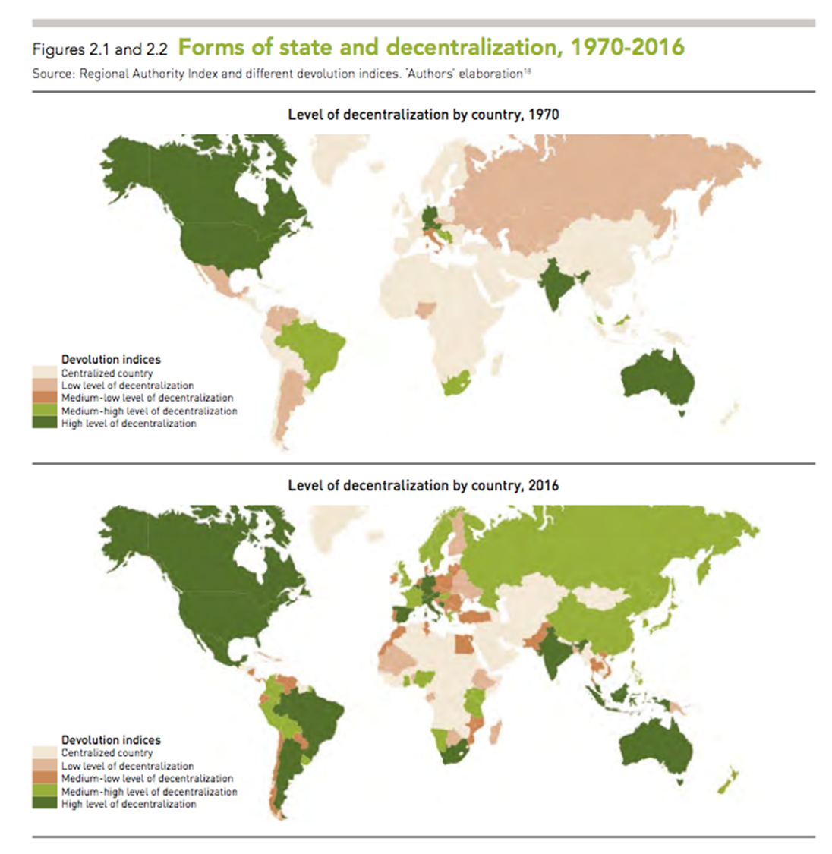
As it can be observed in the following chart, the level of decentralization of the world has increased substantially in the last 40 years. Analyse it depending on the origin of your trainees.
slide x

Call for fiscal reforms
Without the strong commitment of national governments and the international community to reinforce the resources and capacities of local and regional governments, the potential of localizing the SDGs could be left untapped. As recognized by the Addis Ababa Action Agenda on Financing for Development, in more and more countries "expenditures and investments in sustainable development are being devolved to the subnational level, which often lacks adequate technical and technological capacity, financing and support.”
Local and regional governments should call for better local taxation schemes, including new taxes and non-fiscal resources such as rates and service charges, and for the weight of national transfers, especially conditional ones, to be reduced. They should stand up against taxes that are harmful for the environment, like fossil fuel subsidies. Local and regional governments should also work with central governments to improve their borrowing powers and to explore innovative forms of financing local government, including through partnerships with the private sector. Fiscal reforms are often part of a long and complex process, and the implementation of strategic projects to achieve the SDGs should not be postponed. The mobilization of existing available resources and capacities towards achievement of the SDGs at local level is essential.
You can go through the LRG participation in public expenditure and revenues in different regions depending on the origin of your trainees. You will find information in GOLD 2 Report.
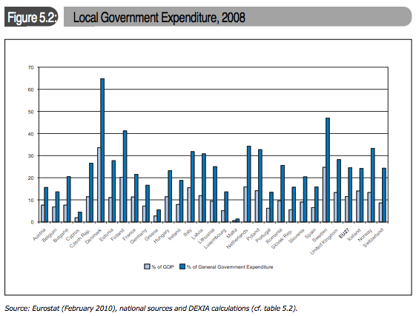
Example: Europe
slide: x
Resource: https://www.uclg.org/sites/default/files/gold_ii_en_0.pdf
Call for multi-level governance mechanisms for the implementation and monitoring of the SDGs
The participation of local and regional governments in the definition of national priorities and strategies relating to the SDGs requires an appropriate institutional framework that allows for different forms of cooperative governance involving both different levels of government (multi-level governance) and other stakeholders (multi-stakeholder governance).
Local and regional government advocacy aimed at national governments and international organizations should call for multi-level governance mechanisms to better facilitate the localization of the SDGs. Multi-level governance has been described as the “decision-making system to define and implement public policies produced by a collaborative relationship either vertical (between different levels of government, including national, federal, regional or local) or horizontal (within the same level, e.g. between ministries or between local governments) or both.”
The success of multi-level governance is determined by three conditions: the principle of subsidiarity, respect for local autonomy, and mutual loyalty, trust and structured dialogue between actors. An integrated multi-level governance approach and dialogue between interdependent institutions can be achieved through mechanisms based on consultation, coordination, cooperation and evaluation, for example, the establishment of a formal committee that brings national, regional and local authorities together, structured dialogues, partnerships, and informal networks. Local leaders play a key role in negotiating successful multi-level governance on behalf of their communities.
Resources:
Addis Ababa Action Agenda on Financing for Development
http://www.un.org/esa/ffd/ffd3/index.html

Enabling environment for the localization of SDGs (exercise)
Icons:
20 min
Group: 2,3
handout: x

Preparation: Print 1 copy handout x for each participant.

At the end of the lecture give handout x to every participant and moderate a debate based on it.

HANDOUT
According to the above, an enabling environment for the localization of SDGs includes:
- A legal and political framework that guarantees democracy and respect for human rights
- A legislative body and level of decentralization that recognizes local and regional governments as an autonomous level of government with legal powers, financial autonomy, clearly defined roles and responsibilities and the capacity to defend the voice of citizens before national authorities
- Multi-level governance mechanisms and multi-stakeholder partnerships
- Recognition of the need to make financial transfers from the central government to local and regional governments in order to correct imbalances between the tasks assigned to them and their limited resources. Local and regional governments should also have the legal power to set their own taxes, with the aim of effectively implementing their locally defined development pathways and ensuring accountability to local communities
- Capacity building of local and regional governments in relation to the SDGs, empowering them to maximize their contributions, even in the face of limited competencies
- Measures to monitor and assess the performance of local and regional governments, as well as to support them to improve over time
- A national urban strategy that takes the SDGs and the New Urban Agenda adopted at Habitat III into account, along with the financial and technical arrangements and capacities necessary to implement it
Local and regional governments should call for their central governments to implement the “international guidelines on decentralization and access to basic services for all” adopted by the Governing Council of UN Habitat in 2007/2009. The Guidelines lay out the principles for the effective decentralization of responsibilities, policy management, decision making authority and sufficient resources, including revenue collection authority.
https://unhabitat.org/books/international-guidelines-on-decentralization-and-access-to-basic-services-for-all/

Following the previous explanations, these questions will help foster the debate amongst the participants:
- According to the world maps above, what has changed in these 40 years in terms of decentralization? What trends do you see? What has been the role of LRGs in the successful decentralization processes, what can we learn from them?
- What channels do LRGs in your territory have if they decide to knock on the national government’s door and advocate for an enabling environment?
- If the national government does not give way to LRGs’ petitions and does not transfer the necessary resources so that they can work on the localization of the SDGs, what should they do? Where can they get financial (or other kinds of) resources from? If they do get the resources from the national government but it is a one-time concession, should they give up calling for an enabling environment?
- In your opinion, why can LRGs perform better at improving non-discriminatory access to basic services than national governments? Do you think national authorities are aware of this fact?
- As regards LRG funding, have you ever heard about microfinance schemes such as crowdfunding? In your territory/country, how important do you think it is to call for an enabling environment in this regard?
- Why would it be positive to include the national government in the monitoring and assessment of the performance of local and regional governments? What multi-level mechanisms do you reckon would be appropriate for that?

Key Chapter 3: SDGs go local. Aligning local and regional development plans

SDGs go local. (Lecture)
Icons:
15 min
Group 1,2, 3
Presentation slides: x, y, z

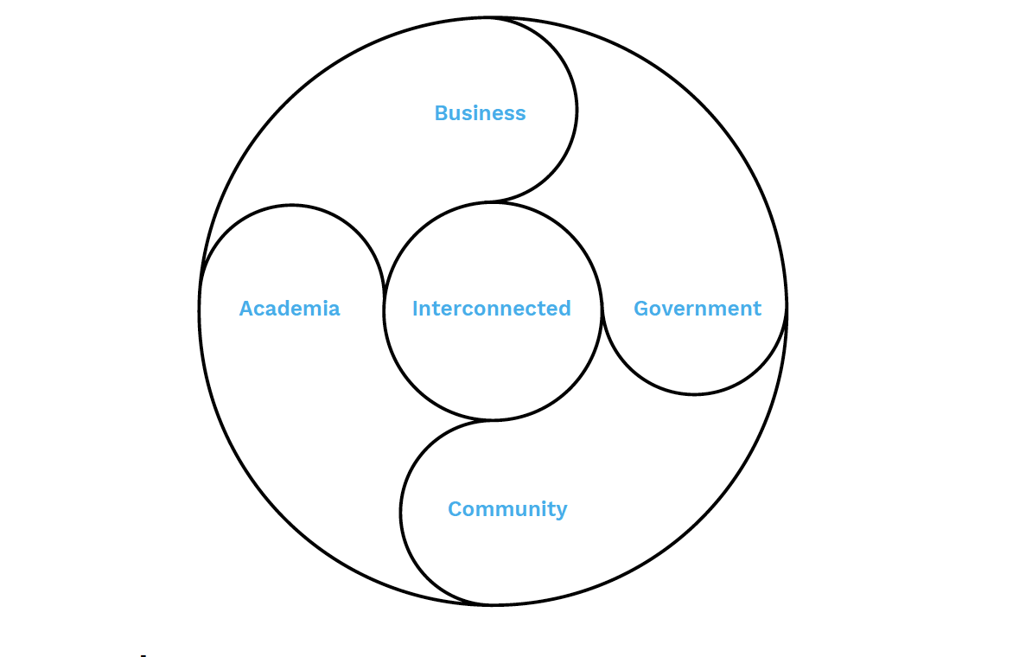

Trainer´s Insights

The implementation of the SDGs should both respond to local and regional needs and priorities and be coherent with, and complement, national strategies.
The role of different levels of government in the implementation of the SDGs depends on the political and institutional framework of each country. Each level of government should have the capacity to set their own priorities in line with their legal areas of responsibility, and to pursue them through local and regional plans and sectoral policies.
In order to set local priorities, existing local and regional plans should be reviewed with the aim of identifying the main needs, priorities, gaps and cross-sectoral linkages of the territory and their relationship with the SDGs and national priorities. It is crucial that local and regional governments ensure their priorities within the framework of the SDGs are relevant and locally-owned, and include the interests of different levels of government and local stakeholders, including minorities and vulnerable groups.
Cooperative governance to establish shared priorities
The whole system of actors, public and private, operating in a territory should establish a common framework of dialogue in order to define the priorities that should be addressed by the SDGs. The following governance mechanisms should be activated to make this possible:
Multi-level governance platforms should ensure coherence between the sectoral priorities of national government departments and those of local and regional governments.
Additional: CASE STUDY - Ecuador
Icons:
5 min,
Group 1, 2
Presentation slides: x

Ecuador’s multilevel governance approach
Ecuador has promoted the establishment of integrated local development systems which allow the national government and the decentralized autonomous governments (DAGs) to coordinate initiatives on issues such as the transformation of modes of production, the effective localization of public policies and investments, and the appropriate management of international development cooperation initiatives.
These integrated local development systems, supported by UNDP, have had the following results:
- At territorial level, coordination and dialogue spaces (Territorial Working Groups) have been institutionalized in most territories through decrees, co-financing of operational costs, personnel seconding and, in general, the adoption of models of international development cooperation management
- At national level, the linking-up of the decentralization and territorial development processes has been incorporated into public resolutions and the plan for the DAG’s capacity strengthening in managing international development cooperation now includes the creation of participatory spaces to join up territorial actors and various levels of government. Additionally, the working strategies of Technical Secretariat of International Cooperation at the territorial level now take root in the relationship between territorial actors and government institutions at different levels
- At international level, the system has been mainstreamed into UNDP’s territorial development approach and strategy

Inter-municipal cooperation, including crossborder cooperation where appropriate, should be used by local governments to jointly assess their needs, define their SDG priorities and develop programmes and plans at territorial level. Local and regional governments should work together to guarantee a more integrated and efficient approach to territorial development through cooperation in service delivery, infrastructures and, where possible, through the pooling of resources and capacities.
Multi-stakeholder mechanisms, both formal and informal, should ensure the participation of civil society organizations, private companies and academia.
These mechanisms should be: accessible to all sectors of society, balanced so that no group dominates any other, and transparent. When everyone has the chance to contribute to the debate with their opinions, information and experience, the process gains legitimacy, but decision-making must be transparent and widely communicated to ensure that the process is accountable and confidence is maintained.
Where possible, existing participation mechanisms should be used for the definition of SDG priorities, rather than ad hoc processes; standing institutional arrangements allow the capacities of civil society representatives to be strengthened over time and trusting relationships of support and cooperation to be developed.
Local and regional governments should play a leading role in multi-stakeholder mechanisms, while respecting the independence of nongovernmental actors. This role could include: ensuring a minimum infrastructure, setting agendas, proposing specific topics, distributing relevant materials or even awarding grants for particular activities.
Additional: CASE STUDY - Azuay (Ecuador)
Icons:
5 min,
Group 1, 2
Presentation slides: x
Civil society involvement in regional planning in Azuay (Ecuador)
The Provincial Government of Azuay defends the principle of the active participation of society, communities and local stakeholders in the process of definition of its plans and actions. In its Territory Vision 2019, Azuay envisaged putting into practice its Participatory Planning System in the process of implementation of the SDGs in its territory. It has used a People’s Provincial Parliament and the Cantonal and Community Assemblies to bring together a wide range of sectors for coherent institutional planning. These initiatives will be complemented by the establishment of cooperation agreements with representatives from the private sector, expert organizations and academia.
Source: Are regions ready? Implementing the SDGs at the subnational level, Nrg4SD Assessment Questionnaire

Aligning local and regional plans with the SDGs (Lecture)
Icons:
10 min
Group 1,2, 3
Presentation slides: x, y, z

This lecture should be given to all the groups even if you are running a short training. However, it is particularly important for Local and Regional Governments. You can explain it more briefly when your target group is Local and Regional Governments Associations. If you have enough time use case studies to illustrate the lecture.

SDG implementation strategies should be defined by aligning current local or regional development plans with the goals, targets and indicators of the 2030 Agenda.
Local and regional plans should provide a comprehensive vision of the territory and define strategies based on an integrated and multi-dimensional approach to inclusive and sustainable development. They should be defined, implemented and monitored with the involvement of the major territorial stakeholders in a context of broad participatory governance.
These plans should include:
- Baseline diagnosis of the socioeconomic and environmental context
- Local or regional priorities and links with SDGs and targets
- Shared targets
- Coherence with SDG-based national (and regional) plans
- Strategic projects
- Budget and financial strategies
- Implementation timeline
- Cooperative governance mechanisms
- Monitoring and assessment tools, including a set of local and regional indicators aligned with the indicators established in the 2030 Agenda

Tip: If you are working with Group 3, and did not use the Stakeholder Mapping exercise for the awareness - raising section you can use it here and skip the Aligning exercise, which might be too abstract for this target group.

Aligning local and regional plans with the SDGs (Exercise)
Icons:
80 min
Group 1, 2 , (3)
handouts: x,x,x
Presentation slides: x, y, z

Preparation: For each group print handout x on A3 format, print official UN Targets and Indicators list, bring copies of What the local governments need to know.

This exercise is a practical application of aligning a local development plan to the 2030 Agenda. We provide two versions of the exercise:

Version 1- an empty alignment board (handout x)

- We encourage you to ask participants beforehand to bring their local development plans and work on their local case.

Divide participants into groups of 3 to 5 people, if possible, from the same local government. It will be easier for them to work on their own local example.

The exercise has 6 stages:

Tip: If you made the Stakeholder Mapping exercise first, start the Alignment exercise from the stage 2 and put the 3 projects from Stakeholder Mapping.

- 10 minutes: ask each group to choose 3 strategic focuses (for example: Urban action strategies to combat climate change) and write down on the board.
- 15 minutes: group should come up with at least one project for each strategic focus.
- 10 min: each group should assign SDG goal to each strategic focus
- 10 min: each group should assign SDG targets to each strategic focus
- 10 min: each group should assign SDG indicators to each project
- 25 min: plennary discussion:
- Can local development plans be easily aligned to the 2030 Agenda?
- Can SDGs serve as a trigger to rethink existing plans?
- Do 2030 Agenda targets fit to local realities?
- How can we guarantee its integrality and the multi-dimensional approach to sustainable development? Involvement of different sectors and departments, coordination, coherence...
- What about the indicators?

Version 2- pre-filled alignment plan based on the fragments of Madrid experience (handout x).

Tip: If you choose version 1 and you see that a group has difficulties with the exercise you can always jump to version 2.

Preparation: For each group print handout x on A3 format, handout x on A4 format, print official UN Targets and Indicators list, bring copies of What the local governments need to know.

This version is designed for Group 3, or other groups that has difficulties to come up with concrete examples.

The timing and the stages of this version are exactly the same as the version 1. The only differences are:
- The board has pre-filled strategic focuses.
- Group does not have to come up with projects examples. You should print cards with projects names from handout x and hand it to the participants. By doing so, participants will work directly with aligning the local development plan with the 2030 Agenda

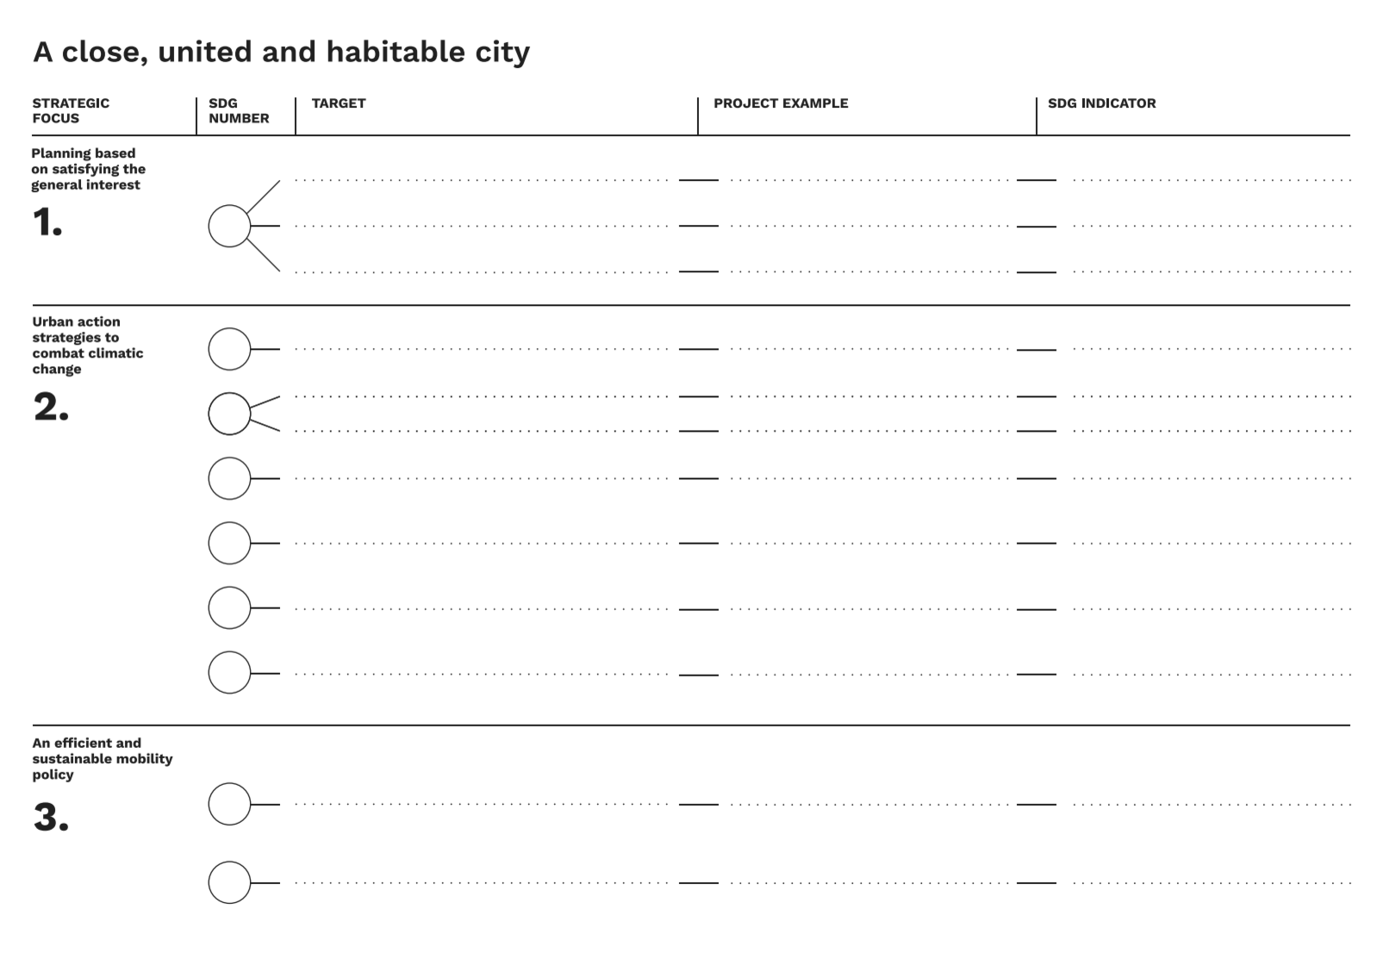

Resources:

SDG Indicators list
What the local governments need to know.

Example
Regional planning and SDG alignment in Wales (UK)
The National Assembly for Wales passed the Well-being of Future Generations (Wales) Act in 2015, the main mechanism by which Wales will contribute to the achievement of the SDGs. The Act puts into law seven well-being goals for Wales based on the principles of sustainable development. These goals reflect the economic, social, environmental and cultural dimensions of sustainable development in Wales. This holistic strategy sets out a comprehensive plan, including indicators and follow-up mechanisms for public bodies and government long-term planning. The Act also establishes the role of a Future Generations Commissioner for Wales and aligns accountability for achieving the goals with the public sector’s overarching purpose. The 2015 Act includes a requirement for Welsh ministers to take account of any action taken by the United Nations in relation to the UN Sustainable Development in their planning for the future, and to assess the potential impact of such action on the economic, social, environmental and cultural well-being of Wales
Resource: http://gov.wales/topics/people-and-communities/people/future-generations-act/?lang=en

Mobilizing local resources
In a context of scarce resources, local budgets should be efficiently aligned with the priorities identified and established in the local or regional development plans. This implies allocating or reallocating available resources to satisfy priorities aligned with the SDGs.
It is also important to improve management skills and capacities within institutions to ensure a more effective use of available resources. This includes:
- Improving organization schemes,
- Tax management,
- Budgeting (including participatory budgeting),
- Public procurement,
- Transparency and the fight against fraud and corruption,
- Providing new and enhanced skills in local and regional government staff through capacity building initiatives in fields as diverse as public debt management and access to private loans.
New partnerships are also needed to mobilize resources and expertise by partnering with the private sector (through public-private partnerships), communities (through public private-people-partnerships) and universities and research centres.
Alternative finance channels should not be neglected: crowdfunding, for instance, raises funds through small contributions from diverse individuals and organizations.
Local and regional governments should also consider working together to pool their services. Whether through informal mechanisms (such as a joint strategy by municipalities or regions to attract new businesses) or through more complex institutional forms of collaboration (ad-hoc associations, consortia, etc.), such intermunicipal cooperation can free up extra resources by harnessing the cost advantages of economies of scale.
A lack of resources and capacities is particularly critical for many intermediary and small cities and rural municipalities and regions. For this reason, regions and intermediate governments play an important role in scaling up high value services and providing technical and financial support in the framework of territorial cooperation mechanisms.

Building capacities for effective and responsive leadership
The implementation of strategic projects and the achievement of the SDGs at local level require adequate infrastructures and equipment, access to technology and innovation as well as qualified human resources.
Capacity building is crucial for the transformation of a territory’s human, scientific, technological, organizational, and institutional capabilities. The achievement of the SDGs requires the empowerment of individuals, leaders, organizations and societies.
Building endogenous capacities within local and regional governments is necessary for institution-building, policy analysis and development management, including the assessment of alternative options. Such actions will enhance actors’ ability to respond to long term challenges rather than concentrating only on immediate problems. In order to achieve this, specific knowledge and skills must be developed to perform tasks more efficiently and mind-sets and attitudes must be changed.
Peer-to-peer learning and capacity building to support local leadership and team-work can be an effective way to improve service delivery, change work streams, address needs, shortfalls and promote problem-based learning. Ideally, peer learning involves local and regional authorities of similar backgrounds, which maximizes management, political and territorial impact.
Examples

Promoting ownership and co-responsibility for the implementation of strategic projects

The implementation of the strategic projects included in SDG-based plans (or aligned plans) should promote the full involvement and participation of local stakeholders (NGOs, private sector, community-based organizations, research organizations, academia and individual citizens). This multi-stakeholder approach should create ownership and co-responsibility among all actors and serve to mobilize and reallocate resources effectively.

Over the last decade domestic resources have been the largest source of financing for development, and CSOs, the private sector and academia have a significant capacity to mobilize, not only financing, but also technology, innovation and talent for sustainable development. While the stakeholders have different interests, expectations and agendas and play different roles, they have a common goal in the sustainable and inclusive development of their territories. Their contribution through different phases (definition, funding, implementation, monitoring and evaluation) should be defined according to their capacities and resources (technical, technological and financial resources, knowledge-based skills, and innovation).

In order for local and regional plans to accurately reflect local needs, public institutions should promote the involvement of citizens, particularly the most vulnerable groups, through mechanisms that facilitate their participation. When citizens are involved in the planning stage of a plan or project, they are usually keener to participate in the implementing and monitoring stages too.

The diaspora can play a crucial role in development, with remittances serving as a powerful financial instrument to achieve SDG related projects at local level, especially in the fields of housing, health or education. In addition, diaspora may contribute with trade, technology and knowledge, also essential for the development of local projects. Harnessing remittances requires local understanding and commitment to action.

Development cooperation

Development cooperation partners can play a role in the implementation of the SDGs by supporting national reforms towards political and fiscal decentralization, and by providing resources, knowledge, experience, technology and innovation to reinforce the institutional and operational capacities of local and regional governments.

Local and regional governments should be able to build direct partnerships with international and national agencies as well as other partners, such as philanthropic organizations, NGOs and the private sector, to access additional funds.

The international community is fostering changes in the way development cooperation is delivered. In order to align their vision and plan for resource allocation with the priorities of the SDGs, development cooperation partners are encouraged to move beyond country eligibility criteria and to work hand in hand with local and regional governments where needs are greatest, thus enhancing policy coherence for sustainable development.

A special effort should be made to align local and regional plans with development cooperation effectiveness principles. This implies going beyond an “aid” approach and building new partnerships for development. Official development cooperation should be based on decentralized cooperation, NGOs, and philanthropic institutions through a wide range of intervention schemes, including north-south, south-south and triangular cooperation.
Decentralised cooperation

Decentralized cooperation partnerships are an optimal way to build platforms for local and regional governments to exchange knowledge and experiences, provide technical assistance, link societies together and generate exchanges among citizens, CSOs, the private sector and universities.

The universal nature of the Agenda is what allows decentralized cooperation to come into play and, what is more, to become an essential tool for the achievement of the SDGs. Indeed, local and regional governments usually face problems that other governments from around the world have already addressed before: the provision of good quality water (SDG 8), the extension of the bus line to enable slum children to attend school (SDGs 10, 11), capacity-building activities for local civil servants in the field of good governance (SDG 16)… It is clear that local and regional governments benefit from partnerships and platforms that foster the exchange of knowledge and experiences and the provision of technical assistance. The universality of the Agenda and the sharing of similar problems give a sense of horizontality, mutual interest and bidirectionality to decentralized cooperation partners, thus breaking with the vertical, aid-centered approach.

Example:

Decentralized cooperation to achieve SDG 8 on decent work and economic growth

In 2012, in the framework of the localization of the decent work agenda, the ILO, UCLG and the city of Maputo organized a learning exchange in the Mozambican capital about the informal economy, particularly the conditions of informal vendors. The main guests were the cities of Durban, Belo Horizonte and Porto Alegre, who had the opportunity to share their extensive experience in the field. Other Mozambican cities, international organizations, NGOs and the private sector were also invited. The learning exchange resulted in the adoption of a roadmap on South-South and Triangular Cooperation for local governments and was followed by a series of technical visits and training sessions in 2013. Durban transferred its experience to informal vendors and municipal officers, while Belo Horizonte shared its expertise on the support of local economy and urbanization. The exchange demonstrated the strategic importance of food markets for local economic development, poverty reduction and cultural diversity, as well as the need for a local government South-South cooperation program. Since then, further peer-learning projects have been held in Barcelona, Lleida, Chefchaouen, Pasto and Borgou.

Key Chapter 4: Monitoring
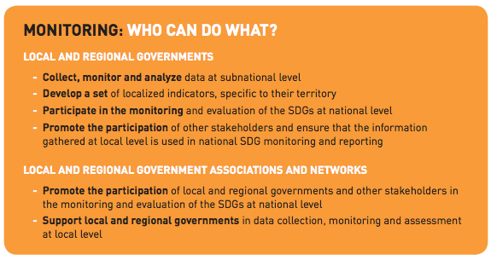
A robust follow-up and review mechanism for the implementation of the new 2030 Agenda for Sustainable Development will require a solid framework of indicators and statistical data to monitor progress, inform policy and ensure accountability of all stakeholders.

The SDGs will be monitored and assessed through a system of 231 indicators. Many of these indicators can be localized by gathering data at territorial level.

Reference
https://unstats.un.org/sdgs/

At national level, follow-up should take subnational data into account in the review of the evolution and concrete results of national plans. Localizing the follow-up of the 2030 Agenda entails the following actions:

- Develop a set of localized indicators, specific to each territory
- Ensure that the information gathered by the local and regional governments is used in national monitoring and reporting
- Enable the participation of local and regional governments and stakeholders in the review of national plans
- Use SDG indicators to monitor and assess local or regional plans
- Ensure that local achievements are recognised and part of the national SDG progress reports
Many local and regional governments lack adequate mechanisms to gather information and data at territorial level and local data sets are often not consistent with national data collection systems. However, there are examples of cities and regions that have created their own statistical institutions to complement planning services. Strengthening these institutions will be essential in order to monitor and assess the achievement of the SDGs at territorial level.

Examples:

INSTITUT D’ESTADÍSTICA DE CATALUNYA

or

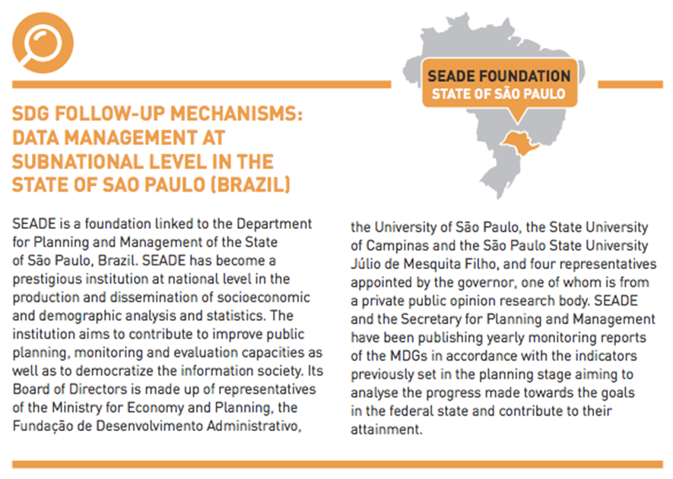

Promote the participation of local and regional governments in national monitoring

Most countries’ monitoring systems are administered by a national statistical office or national planning service. In other countries, the systems are the competence of an intersectoral commission or council made up of representatives of different ministries. In either case, local and regional governments should seek to take part in the national follow-up and review of the implementation of the SDGs. The follow-up process should be transparent in order that its results serve to hold local and regional governments and other participating stakeholders accountable and to harness the best experiences to transfer knowledge to other municipalities, regions or countries.

Example:

VER QUÉ EJEMPLO PODEMOS APORTAR. COLOMBIA?

Collect data and monitor progress at subnational level

One of the important lessons from the MDGs was that progress should not only be tracked at national level. The UN has undertaken a special effort to make monitoring at local and regional level a priority in case of the SDGs. The establishment of data collection systems at local and regional level is a fundamental in order to disaggregate information “by income, gender, age, race, ethnicity, migratory status, disability, geographic location and other characteristics relevant in the national context” (SDG Target 17.18) and to monitor processes and results through indicators.

Cooperation agreements should be signed by different levels of government to ensure the exchange of information. A ‘data revolution’ should be promoted to contribute to the monitoring and achievement of the SDGs. Again, universities, research centres, and even NGOs and the private sector, can help in the task of collecting, monitoring and analysing data.

Example:

PODEMOS PONER ALGÚN EJEMPLO?

Adapt national indicators to local and regional context

The definition of local or regional SDG plans, or plans aligned with the SDGs, should include a set of indicators linked to those of the 2030 Agenda and adapted to each territory’s needs and context. Local and regional governments should define these indicators according to their data collection capacities, including their human resources and technological facilities. Indicators should also take into account the diversity of territories. Thus, in line with the SDG motto of “leaving no one behind”, they should include social groups at risk of exclusion (that is, groups that usually fall far below the average indicators). Similarly, countries with special circumstances such as fragile, conflict-affected, landlocked or less developed countries or small islands might need to include additional indicators to better reflect and monitor their specific circumstances and needs. As for the monitoring and evaluation of local or regional plans, local governments should set up joint initiatives to create strong subnational mechanisms supported by independent review processes. When resources and capacities do not allow for the creation of subnational mechanisms, local and regional governments should ensure that the national authorities collect data from all the different territories in a comprehensive manner.

Example on how to localize indicators:

SDG Target | UN Indicator | Local Indicator | Source
Goal 11. Make cities and human settlements inclusive, safe, resilient and sustainable 11.1 By 2030, ensure access for all to adequate, safe and affordable housing and basic services and upgrade slums | 11.1.1 Proportion of urban population living in slums, informal settlements or inadequate housing
11.2 By 2030, provide access to safe, affordable, accessible and sustainable transport systems for all, improving road safety, notably by expanding public transport, with special attention to the needs of those in vulnerable situations, women, children, persons with disabilities and older persons | 11.2.1 Proportion of population that has convenient access to public transport, by sex, age and persons with disabilities
Source: own

Reporting: National Voluntary Reports (Exercise)

Icons:
10 min,
Group 1, 2, 3
Presentation slide: x

Some countries are conducting regular and inclusive reviews of progress at the national and sub-national levels, which are country-led and country-driven. These national reviews are expected to serve as a basis for the regular reviews by the high-level political forum (HLPF), meeting under the auspices of ECOSOC. As stipulated in paragraph 84 of the 2030 Agenda, regular reviews by the HLPF are to be voluntary, state-led, undertaken by both developed and developing countries, and involve multiple stakeholders.
The voluntary national reviews (VNRs) aim to facilitate the sharing of experiences, including successes, challenges and lessons learned, with a view to accelerating the implementation of the 2030 Agenda. The VNRs also seek to strengthen policies and institutions of governments and to mobilize multi-stakeholder support and partnerships for the implementation of the Sustainable Development Goals.
Following this link you can log in the online review platform, dedicated to compiling information from countries participating in the voluntary national reviews of the High-level Political Forum on Sustainable Development.
You will find information on your country of interest. It is possible to filter this information by suggested keywords such as “local government”.
Tip: Pay attention! Filters use keywords in English and do not recognize keywords in other languages.
Examples:
Colombia click here
Colombia was part of the 2016 voluntary national reviews. The voluntary report (in Spanish) presented to the HLPF2016 includes some interesting points for discussion:
The SDGs conceived as a tool to build on the peace process
Alignment of the National Development Plan with the SDGs
Governance of the Agenda at national level: establishment of a High Level Commission on SDGs with the participation of representatives of the national government, local authorities and national stakeholders (CSOs, private sector, academia)
Focus on the implementation at sub-national level. Alignment of sub-national plans with the SDGs (pages 10 to 14 of the full report), with detailed information on departments and cities that have already aligned their development plans and data on the top SDGs (SDG 4 and 16 are included in the 100% of the plans, and SDGs 3, 8 and 11 in the 98%).
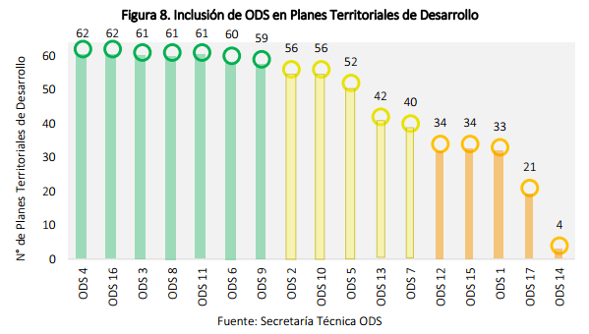
The report also shows which targets respond to sub-national competences (at department and city level). Sub-national governments are co-responsible in 30% of the 169 targets. The following are the targets most frequently included in city or department development plans:
9.1 quality, reliable, sustainable and resilient infrastructure
10.2 empower and promote the social, economic and political inclusion of all
4.1 ensure that all girls and boys complete free, equitable and quality primary and secondary education leading to relevant and effective learning outcomes
16.7 responsive, inclusive, participatory and representative decision-making at all levels
Resources:
Voluntary national reviews
https://sustainabledevelopment.un.org/vnrs/

The following table shows in which countries LRGs have been involved in the preparation process of VNR.

HANDOUT
Country/National Association | National level | L&R level
Voluntary National Review 2016
Norway (KS) | Norway developed a Voluntary National Review in 2016. The Norwegian Association of Local and Regional Authorities (KS) has provided input on behalf of local governments on the review. There are regular consultative meetings between the central government and local authorities. These consultative meetings take the form of plenary meetings and bilateral meetings between KS and ministries.
Colombia | Colombia submitted their VNR in 2016. It included local governments as an important partner in the implementation of the SDGs
Voluntary National Review 2017
Sweden (SKL) | SKL is often consulted by Ministry of Foreign Affairs and the Ministry of Finance regarding the SDGs and the Voluntary National Review. SKL is a member of the Swedish Government’s reference group that has been created to discuss the development of VNR - Several Swedish municipalities are also members of thes group. SKL has gathered examples from municipalities on how they work with sustainable development and how they have approached Agenda 2030. 40 examples were put in a report, given to the Ministry. A few of those local governments which have done good work will probably be invited by the central government to talk about the implementation of the SDGs and join the ministry to New York in the context of the Voluntary National Review. | In Sweden the implementation of the SDGs has been a very bottom-up process. SKL’s message to the central government is that municipalities should themselves define what the sustainability challenges are and how to tackle them – and then later link them to the global framework.
The Netherlands (VNG International, CBS) | VNG International will write a chapter on the role of subnational governments in the implementation of the SDGs for a report which will form the base for the Dutch Voluntary National Review. VNG International is also member of a group of focal points; VNG International represents subnational governments, other members of the group represent the various ministries | VNG International provides support to Dutch municipalities regarding the translation of Agenda 2030 to the local context. They help set up local meetings, created a menu on the website with different ways on how to work on SDGs and advice on how to get more sustainability in implementation of laws. However the campaign is still in the early stage of awareness raising.
 | In the Netherlands, Urban Data Centres are connecting local governments and the national statistics institute (CBS). In this way more concentrated data will be available for cities to evaluate and improve their sustainability policies. (Article CBS ; Article Cityscope)
Belgium (Association of Flemish Cities and Municipalities (VVSG)) | VVSG has written a contribution to Belgium’s VNR including activities from both the association and municipalities. It is however not certain yet whether the contribution will be included. | VVSG International informs, raises awareness among and supports municipalities so they get familiar with the SDGs and can implement them in their local policies. They have developed a SDG charter which municipalities can sign and commit themselves to the Sustainable Development Goals. So far, already 48 municipalities have signed the SDG Charter. They have also developed a publication to support to local governments on how to localise the SDGs
Brazil (CNM) | CNM has joined the dialogue on Brazil’s Voluntary National Review. The national government has not yet started to actively prepare for the review, but they are looking at local governments to see what they are already doing and what they can use from that. | Mayors have received a guide (in Portuguese) that presents the importance of the SDGs and outlines its relation to the municipal competences. As a next step, CNM and UNDP ART are developing a publication and distance-learning course on how to integrate the SDGs into the Multi-Annual Municipal Plans 2018-2021, as well as a SDG’s monitoring system for the Brazilian municipalities. All these tools will also feed into the virtual Toolbox for Localizing the SDGs of UCLG, UN Habitat and UNDP
UK (LGA of England and Wales, Bond) | LGA together with Commonwealth Local Government Forum (CLGF) submitted written and oral local evidence to an inquiry into UK implementation of the SDGs by The International Development Committee (committee of the House of Commons in Parliament of the UK)

Reference:
Voluntary National Reports
https://sustainabledevelopment.un.org/vnrs/

Reporting. LRGs-based Country reports

At the international level, the follow-up and reporting processes have been conceived as a responsibility of national governments and UN agencies.

However, a higher the involvement of LRGs in this process is suitable. In this context, UCLG is proposing their members to:

- Participate in the Voluntary National Reviews (VNRs) that their national governments are preparing for the UN;
- Develop LRG-based Country Reports as an instrument to present and assess their contribution to the achievement of these ambitious goals.
To maximize this potential, LRGs should already start contacting their national government to participate in the development of the Voluntary National Reviews on SDG implementation that the UN High-Level Policy Forum on Sustainable Development (HLPF) is collecting from member states.

On the other hand, the LRGs Country Reports can highlight the role that LRGs can play in the localization of the SDGs,1 and emphasize the link between national policies, subnational governance and the challenges of localizing the global agendas. The perspective of LRGs is an indispensable contribution to the localization and reporting processes.

LRG Country Reports will be the backbone of UCLG’s collective effort that will lead to a global report on localization in 2019.

Structure of the LRGs Country Report
It is expected that each country carry out up to two voluntary reviews to be presented to the UN HLPF between 2015 and 2030. The UN Guidelines for Voluntary National Reviews2 provide national governments with a structure to develop their national country reports. They also ask national governments to include a reference to the “policy and enabling environment” that they are creating to involve different levels of government and stakeholders. This proposal for LRGs Country Reports adapts the VNR structure so that the reports present the perspective, needs and concrete experiences of LRGs. In this regard, their analysis would complement (or enhance, whenever necessary) the central governments’ VNRs, assessing them through the eyes of sub-national governments.
The structure of LRGs Country Reports, designed to be about 4 or 5 pages long, could follow these guidelines:
1. Summary (half a page). A valuable report summary would highlight the crucial role of LRGs in “localizing” the SDGs; stress good practices or effective initiatives; and advance LRGs’ key recommendations to support the localisation of the SDGs.
2. Introduction (two paragraphs). It would be useful for reports to quickly introduce the national context in which LRGs are acting. The report could provide insights on the situation of LRGs in their country with some key figures such as the number of sub-national governments and tiers (e.g., states, counties, municipalities) and their key responsibilities – e.g., basic service provision, urban and territorial planning, etc. Core data on local finances – e.g., the ratio of local revenues, expenditures and investments compared to those of national governments – can also be extremely valuable to assess the share of national budgets allocated to LRGs. A few guiding questions can be useful for filling this part in: has the country started the actual SDGs implementation process? In which areas has the involvement of LRGs is considered particularly critical for the achievement of the SDGs? LRGs were also invited to mention the main priorities that may need more urgent action (e.g., slum upgrading, access to basic services, climate change mitigation). They should report on what the key challenges that LRGs are facing for the implementation and, more specifically, for the ‘localization’ of SDGs in their country (e.g. weak decentralization, financing, access to technology, etc.).
3. Methodology and process for the preparation of the review (one paragraph). Explain how this note has been elaborated: who have been consulted (e.g., national local government leaders, a significant group of mayors). It can shed light to what extent LRGs (and their national associations) have been consulted for the Voluntary National Review, and to what extent their views have been considered.
4. Policy and enabling environment (2 pages). This part is the core of the Country Report in terms of contents. A few dimensions are key:
- Creating ownership of the Sustainable Development Goals. The LRGs’ report should emphasize the initiatives developed in the country to raise awareness – among LRGs – on the SDGs and their implementation (e.g., conferences, dedicated campaigns organized either directly by LRGs or by other actors, such as national governments, NGOs, etc.). Mention any initiative undertaken by local and regional governments to support the SDGs (e.g., declarations, action plans, etc.).
- At the national level – Involvement of LRGs in national institutional mechanisms and national plans for SDG implementation. The involvement of LRGs and national associations at various stages of the localization process can vary significantly from one country to the other. The report should provide evidence, if any, of national consultations, conferences or fora, as well as new national institutional structures that have been designed to facilitate and support the participation of LRGs in the implementation of the SDGs. The LRGs Report can provide an analysis of the current national policies and assess whether or not these support LRGs responsibilities and facilitate the collaboration between national and local governments on SDG implementation (e.g., initiatives on basic services, housing, urban planning, etc.). Are there any planned reforms of national legislations, regulations, policies or programmes that support LRGs in the implementation of SDGs? Do these reforms facilitate the involvement of civil society and economic stakeholders in the implementation agenda, especially atthe local level? Have there been any national initiatives to facilitate the production of and access to disaggregated data for LRGs?
- LRG-driven initiatives to localize the SDGs. Whenever possible, LRGs should use their report to provide in-depth analysis on their own initiatives. LRGs should highlight, in particular, whether and how they have updated their local plans to make them consistent with the SDGs and their implementation. They should emphasize any innovative policies put into practice to promote the localization of the Goals and any new partnerships with civil society and the private sector aiming to achieve them. Their narration can focus on successes and challenges, emerging issues and lessons learned. In their account, we invite LRGs to refer – whenever possible – to SDG indicators collected by national and international institutions, but, if needed, they can also contribute any additional indicators that they deem relevant.
5. Means of implementation (half a page max.). This section explores the evolution of local financing, resource decentralization and consistency with local responsibilities and localization support. A key question guiding this assessment is what needs to be improved and what lessons can be learned, resource-wise, in order to achieve the objectives of localization and further promote social inclusion.
6. Conclusion: A summary of the findings, identifying where LRGs would need help with regard to capacity-building, finance, legislative reforms, partnership, technology support, etc.
Reference:

Guidelines for Local and Regional Governments’ Country Reports
https://dl.dropboxusercontent.com/u/63774326/0.Circulars_2017/Circular_3_Localization/ENG_Guidelines_for_LRGs_Country_Report.pdf

Stephenson 2013. Twenty years of multi-level governance: Where Does It Come From? What Is It? Where Is It Going? https://halshs. archives-ouvertes.fr/hal-01024837/document
Based on the criteria shared by UCLG in http://www.afriquelocale. org/en/component/k2/item/318-publication%20-assessing-theinstitutional-environmentof-local-governments-in-africa
Report of the European Economic and Social Committee on the Opportunities and processes for civil society involvement in the implementation of the post-2015 agenda in the EU www.eesc.europa.eu/?i=portal.en.nat-opinions.35521

